PRACTICAL 3 : Traffic Signal

Aim : To simulate a traffic signal system using LEDs and Arduino.

Overview :
This project simulates a real-world traffic light system using LEDs and Arduino. It introduces concepts of sequential control, timing and real-time decision-making, which are essential in IoT-based automation systems. The practical helps in understanding how microcontrollers manage multi-step processes.

Materials Required :
- Arduino Uno R3
- 3 x LED (Red, Yellow, Green)
- 3 x 1kΩ Resistor
- Jumper Wires
- Arduino IDE (Installed on your Computer)

Circuit Connection and Steps :
- Connect the LEDs to the Arduino :
  - Insert the three LEDs (Red, Yellow, Green) into the breadboard.
  - Connect the anode (long leg) of each LED to the following Arduino pins :
    - Red LED : Pin 13
    - Yellow LED : Pin 12
    - Green LED : Pin 11
  - Connect the cathode (short leg) of each LED to the ground (GND) pin on the Arduino through a 1kΩ resistor.
- Set up the Arduino environment:
  - Open the Arduino IDE on your computer.
  - Select the correct board and port from the "Tools" menu.

Circuit Diagram :
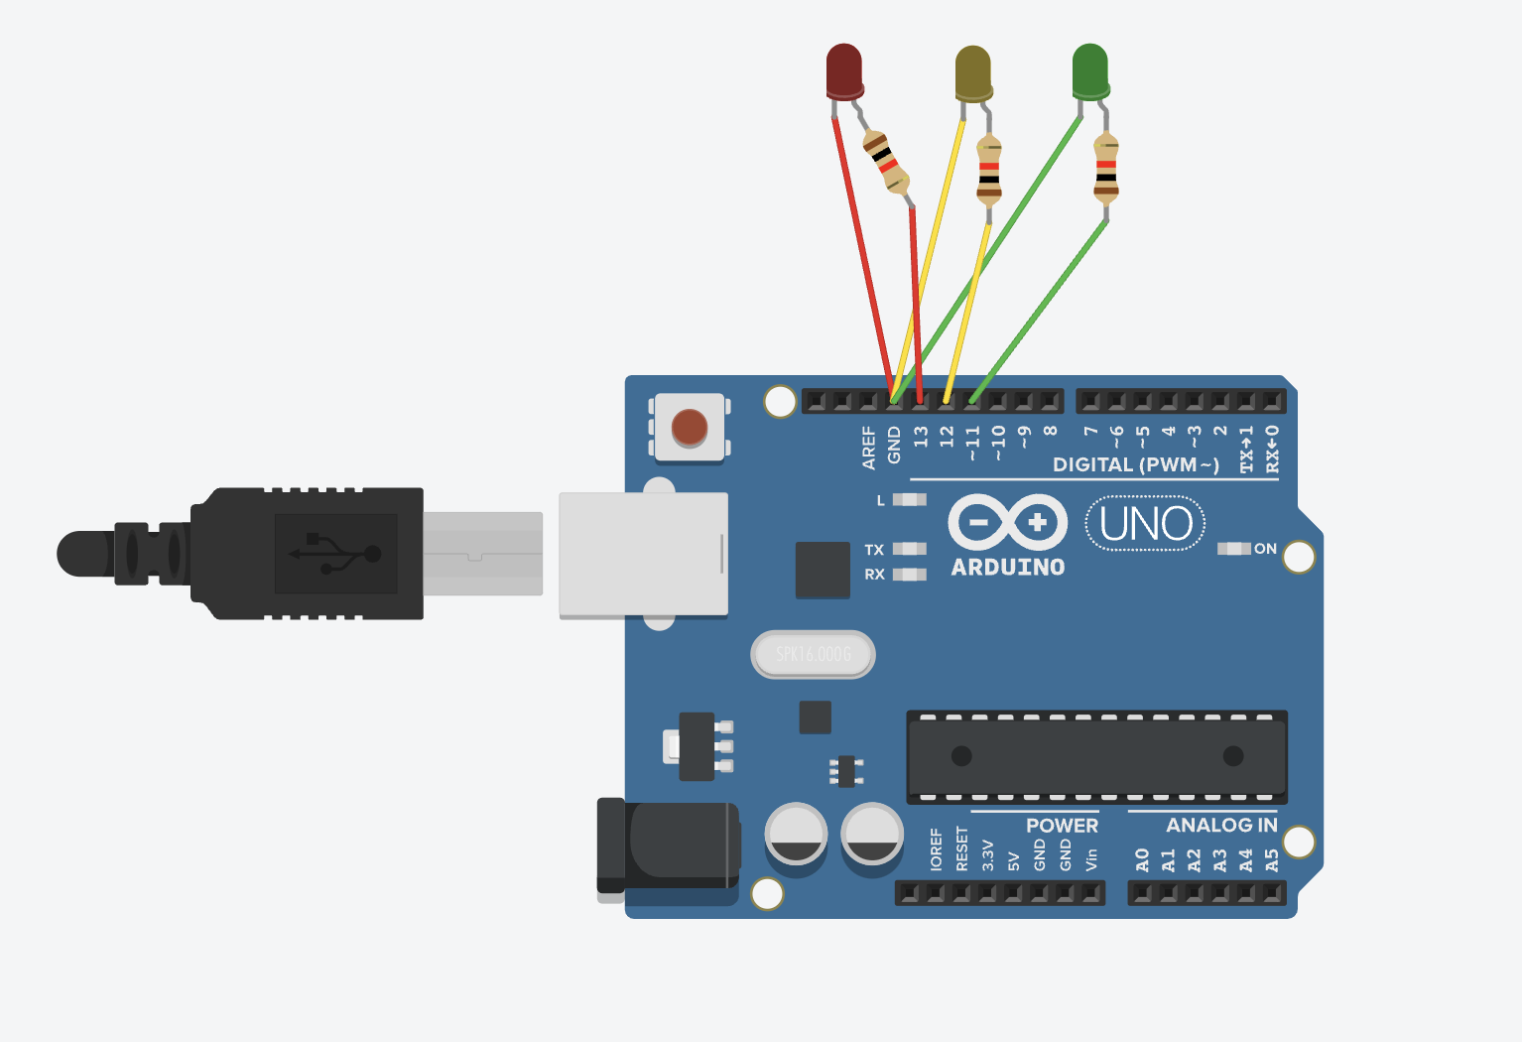
Schematic Diagram :
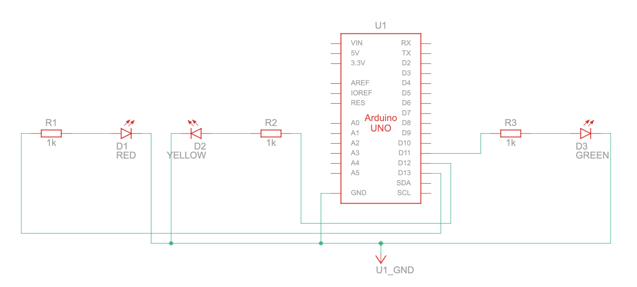

Code :
// C++
// Define the pin connections for the LEDs

int redPin = 13;
int yellowPin = 12;
int greenPin = 11;

// Setup function runs once when the program starts
void setup() {
// Set the LED pins as OUTPUT
pinMode(redPin, OUTPUT);
pinMode(yellowPin, OUTPUT);
pinMode(greenPin, OUTPUT);
}

// Loop function runs repeatedly
void loop() {
// Green light for 5 seconds
digitalWrite(greenPin, HIGH); // Turn on Green LED
digitalWrite(yellowPin, LOW); // Turn off Yellow LED
digitalWrite(redPin, LOW); // Turn off Red LED
delay(5000); // Wait for 5 seconds
// Turn off Yellow LED

// Yellow light for 2 seconds
digitalWrite(greenPin, LOW); // Turn off Green LED
digitalWrite(yellowPin, HIGH); // Turn on Yellow LED
digitalWrite(redPin, LOW); // Turn off Red LED
delay(2000); // Wait for 2 seconds

// Red light for 5 seconds
digitalWrite(greenPin, LOW); // Turn off Green LED
digitalWrite(yellowPin, LOW); // Turn off Yellow LED
digitalWrite(redPin, HIGH); // Turn on Red LED
delay(5000); // Wait for 5 seconds
}

Results :
The traffic signal system will cycle through the following pattern :
- The Green LED will light up for 5 seconds (allowing traffic to go).
- The Yellow LED will light up for 2 seconds (indicating the transition from Green to Red).
- The Red LED will light up for 5 seconds (indicating a stop for traffic). This cycle will repeat indefinitely, simulating a basic traffic signal system

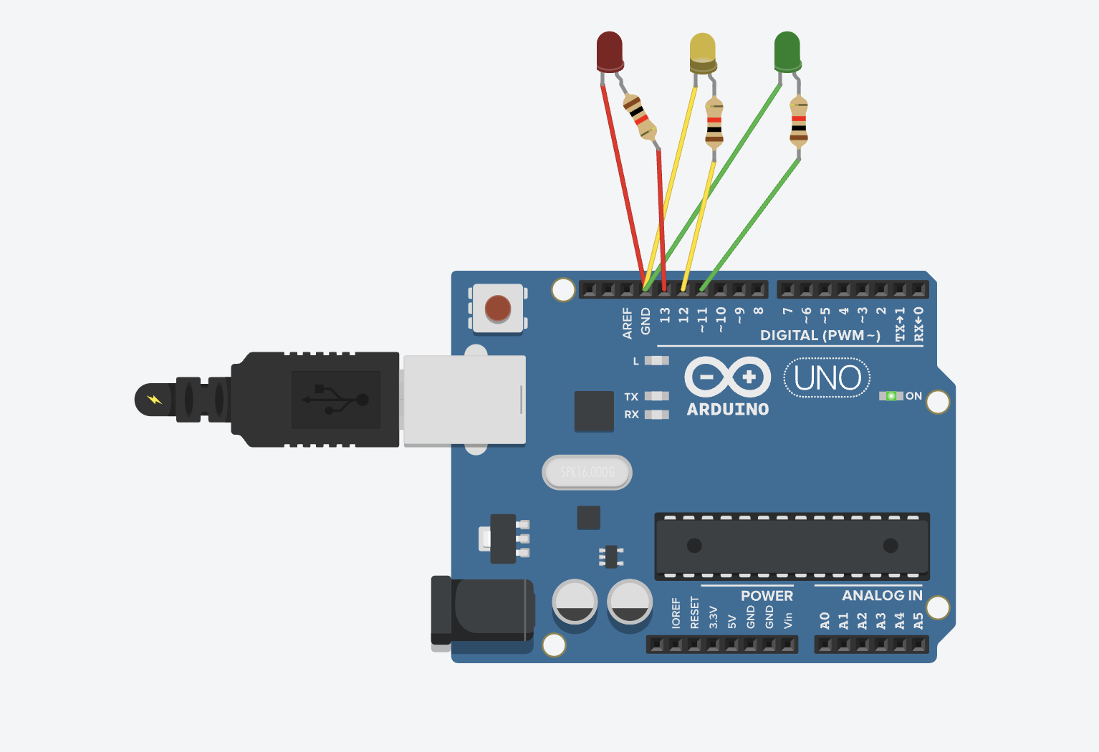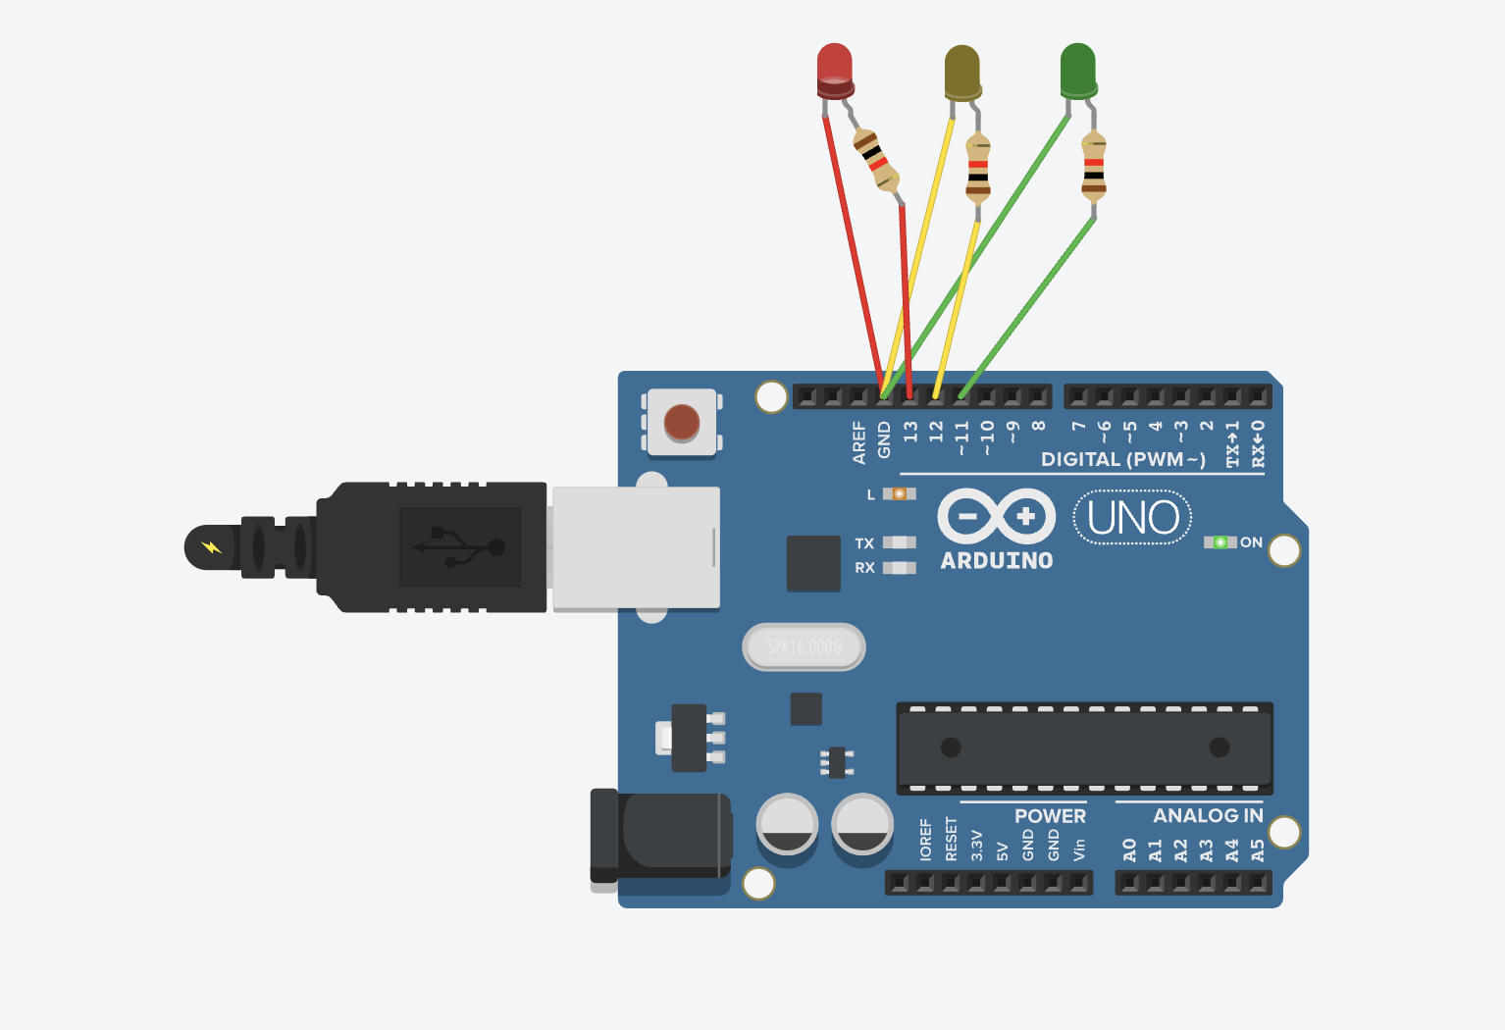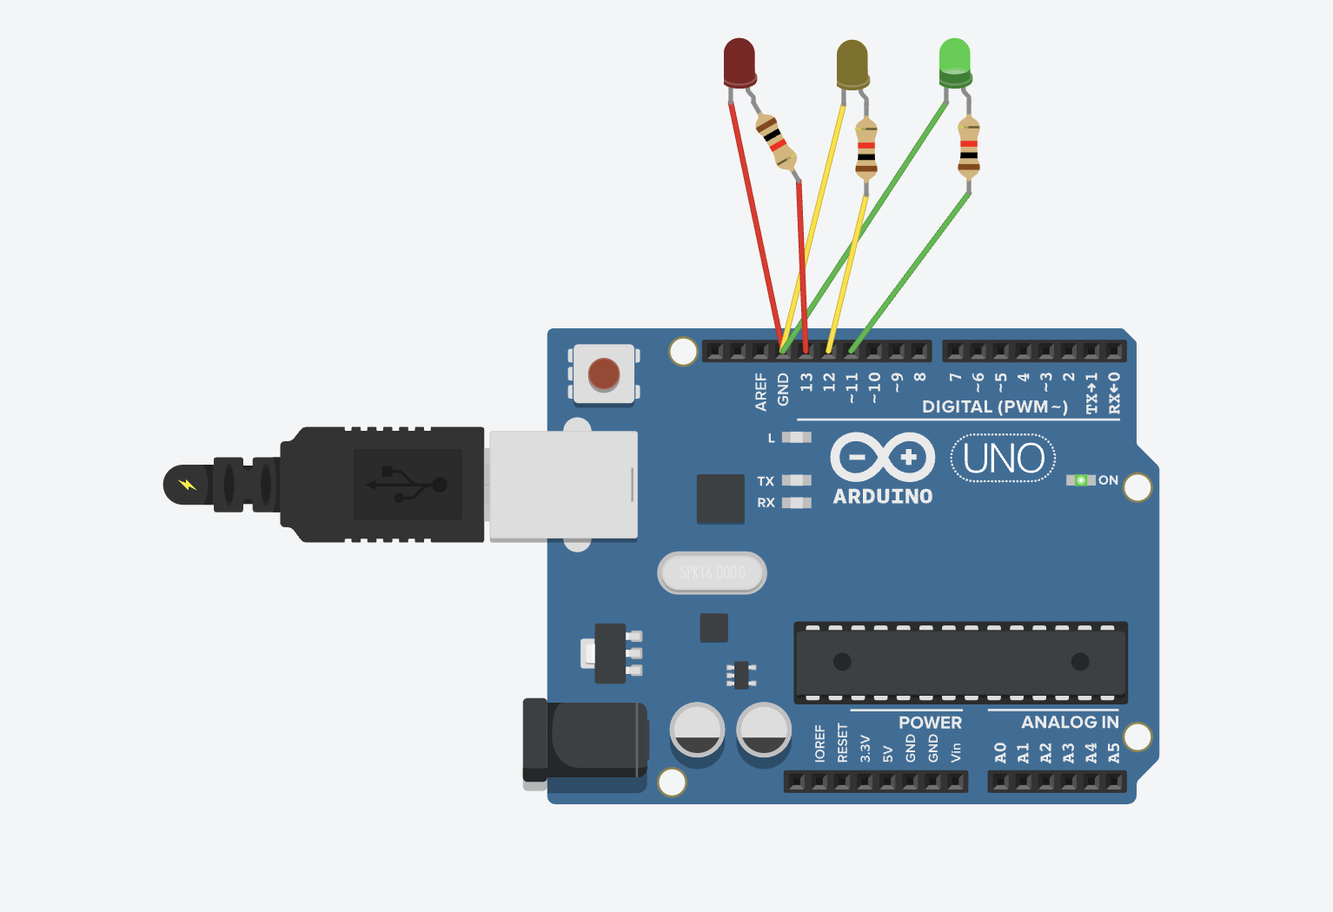

Conclusion :
The Traffic Signal project successfully simulates real-world traffic light control using Arduino. It demonstrates the concept of sequential execution, timing control and LED management. This experiment provides insight into automation in smart city applications and real-time embedded system design.

